
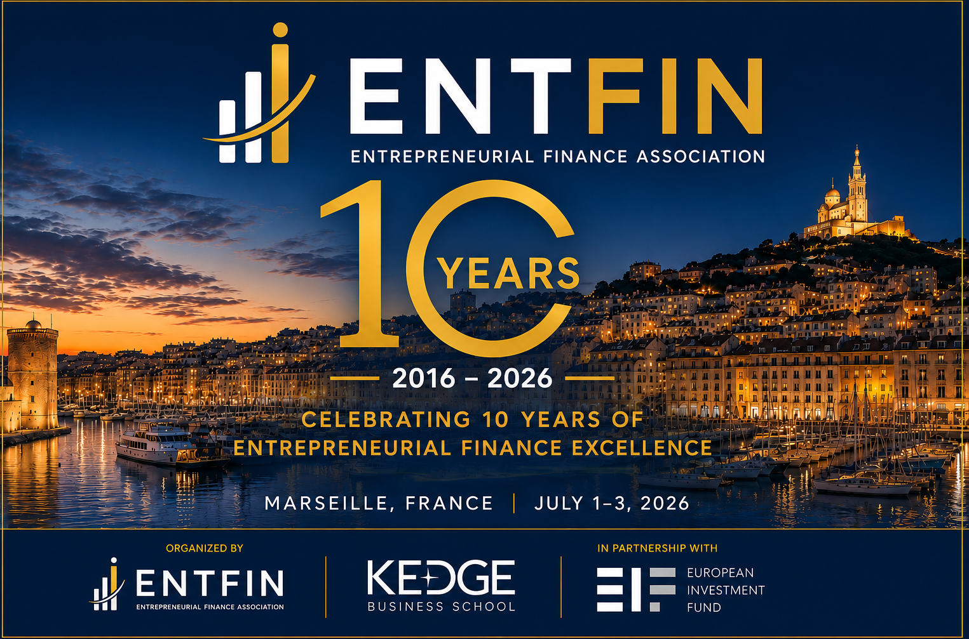
ENTFIN 2026
10th Anniversary Conference
Program (First draft)
Marseille, France | July 1–3, 2026
PhD Workshop: Wednesday, July 1, 2026
Session 1- Crowdfunding and Investor Dynamics Chairperson: Massimo Colombo Wednesday, July 1, 2026- 2:00 PM- 3:30 PM
Dynamics in heterogeneous co-investment syndicates: founder control and firm outcomes | Pre-Money Valuations in Equity Crowdfunding: Foreign Firm Level and Sensitivity Effects
Presenter: Angi Hojer | Presenter: Xinting Shen
Session 2- Entrepreneurial Motivation and Funding Choices Chairperson: Aurélie Sannajust Wednesday, July 1, 2026- 2:00 PM- 3:30 PM
Tell me how you feel, and I’ll tell you about your crowd: How entrepreneur motivation influences crowdfunding modality choices | Funders to Founders: How Prior VC Experience Shapes Resource Acquisition and Startup Performance
Presenter: Federico Carlo Maria Malerba | Presenter: Vittoria Di Marcantonio
Session 3- Corporate Venture Capital and Strategic Resources Chairperson: Vincenzo Capizzi Wednesday, July 1, 2026- 2:00 PM- 3:30 PM
Beyond Ideal Types: An Inductive and Data-Based Approach to Corporate Venture Capital Programs | The Dual Role of Firm’s Resource Redeployment Capabilities in Corporate Venture Capital Relationships
Presenter: Fiammetta Grieco Cinquegrana | Presenter: Noah Lauffer
Session 4- Governance and Specialized Finance for SMEs Chairperson: Job Andreoli Wednesday, July 1, 2026- 2:00 PM- 3:30 PM
Boards, growth, and survival of Italian new ventures | Debt specialization in SMEs
Presenter: Nina Marien | Presenter: Ekin Bayram
Session 5- Private Credit and Entrepreneurial Finance Chairperson: Job Andreoli Wednesday, July 1, 2026- 5:00 PM- 6:30 PM
Value is in the Eye of the Beholder: Strategic Marketing in Private Credit | Climate risk, market structure and efficiency: Implications for bank performance in the eurozone
Presenter: Sameh Marei | Presenter: Violeta Bringas Fernándeza
Session 6- Private Equity, Valuation and Systematic Risk Chairperson: Yan Alperovych Wednesday, July 1, 2026- 5:00 PM- 6:30 PM
EPA-Based Environmental Performance and Exit Valuation of Private Equity Backed Firms | Lucky Beta: The Timing Wedge and Capital Misallocation in Private Equity
Presenter: Shangjie Li | Presenter: Mats Lützenkirchen
Session 7- Sustainable Impact and Intent-Output Gap Chairperson: Massimo Colombo Wednesday, July 1, 2026- 5:00 PM- 6:30 PM
Growing With or Away from Sustainable Impact? Firm Growth and the Dynamics of the B Corp Certification | Moral Ambition and the Intent-Output Gap in Impact investing: A system and paradox perspective
Presenter: Mareta Princesia Deviesa | Presenter: Arthur Dumas

Main Conference: Thursday, July 2, 2026

Session 1- Venture Capital Governance and Monitoring Chairperson: Antonia Watzinger Thursday, July 2, 2026- 9:00 AM- 10:30 AM
Control or convergence? The conditional influence of VC investor trait aggressiveness on syndication dynamics | From Seed to Series: How Venture Capitalists govern Seed-Stage Venture | Matched But Misaligned? Tie Formation and Innovation in Government Private Venture Capital
Presenter: Jonas Bickert | Presenter: Bastien Clergue | Presenter: Antonia Watzinger
Discussant: Bastien Clergue | Discussant: Antonia Watzinger | Discussant: Jonas Bickert
Session 2- Building and Managing Venture Capital Portfolios I Chairperson: Yan Alperovych Thursday, July 2, 2026- 9:00 AM- 10:30 AM
A Portfolio Approach to Venture Capital Financing | Using Machine Learning to Estimate the Effect of General Partners on Venture Capital Performance
Presenter: Yan Alperovych | Presenter: Corrado Botta
Discussant: Corrado Botta | Discussant: Yan Alperovych
Session 3- Private Equity I Chairperson: Charlotte Sun Clausen-Jørgensen Thursday, July 2, 2026- 9:00 AM- 10:30 AM
Traditional private equity-backed buyouts versus partial exits — Shifting governance from monitoring to coordinating | Private Equity Acquisitions: Inorganic Growth and Exit Strategies | Private Capital Fund Performance and Return Persistence When the Managing Firm Goes Public
Presenter: Luc Wynant | Presenter: Charlotte Sun Clausen-Jørgensen | Presenter: Sara Ain Tommara
Discussant: Sara Ain Tommara | Discussant: Luc Wynant | Discussant: Charlotte Sun Clausen-Jørgensen
Session 4- Venture Capital Ecosystems and Public Policy Chairperson: Pia Helbing Thursday, July 2, 2026- 9:00 AM- 10:30 AM
Revisiting Government Venture Capital Effectiveness: Evidence from knowledge flows in European VC Portfolios | Start-ups in the Shadows: Venture Capital and incorporation the case of Panama | Costly intervention? The effects of VC investor trait aggressiveness on founder turnover and venture funding
Presenter: Antonia Watzinger | Presenter: Pia Helbing | Presenter: Jonas Bickert
Discussant: Jonas Bickert | Discussant: Antonia Watzinger | Discussant: Pia Helbing
Session 5- Venture Debt and Bankruptcy Chairperson: Pynadath Minnu Thursday, July 2, 2026- 11:00 AM- 12:30 PM
Bankruptcy Laws meet Social Norms: Real Effects on Entrepreneurial Reentry | Bankruptcy quarantines | Venture Debt and Access to Subsequent External Financial Resources of High-Growth Ventures: A Certification Perspective
Presenter: Mascia Bedendoa | Presenter: Kasper Meisner Nielsen | Presenter: Pynadath, Minnu
Discussant: Kasper Meisner Nielsen | Discussant: Pynadath, Minnu | Discussant: Mascia Bedendoa
Session 6- Venture Capital Performance and Valuation Chairperson: Max Berre Thursday, July 2, 2026- 11:00 AM- 12:30 PM
Startup Valuation Risk: Measuring Certainty and Uncertainty | Statistical Inference for the Public Market Equivalent: A Block Bootstrap Approach | Towards Solving Pension Funds' VC Dilemma: A Monte Carlo Approach
Presenter: Max Berre | Presenter: Corrado Botta | Presenter: Job J. Andreoli
Discussant: Job J. Andreoli | Discussant: Max Berre | Discussant: Corrado Botta
Session 7- Entrepreneurial Finance Markets I Chairperson: Andrea Odille Bosio Thursday, July 2, 2026- 11:00 AM- 12:30 PM
Entrepreneurs’ financing choice between Business Angels and Venture Capital firms: A trade-off between money and costs | Innovation Meets Incentives: Strategic misalignment in Revenue-Based Financing | Persistent and Democratized Entrepreneurship: The impact of reward-based Crowdfunding
Presenter: Andrea Odille Bosio | Presenter: Yifei Wu | Presenter: Benjamin Le Pendeven
Discussant: Yifei Wu | Discussant: Benjamin Le Pendeven | Discussant: Andrea Odille Bosio
Session 8- Behavioral Entrepreneurial Finance I Chairperson: Ivana Vitanova Thursday, July 2, 2026- 11:00 AM- 12:30 PM
Dark traits and financial exposure: An analysis of divergent patterns of angels' commitment | Trading Up? VC Narcissism, Humility, and Status Asymmetry in Syndicate Formation | Too Proud to Fail: The Impact of Managerial Narcissism on Bankruptcy Initiation
Presenter: Mira Knauer | Presenter: Niklas Keuler | Presenter: Ivana Vitanova
Discussant: Ivana Vitanova | Discussant: Mira Knauer | Discussant: Niklas Keuler
Session 9- Entrepreneurial Finance Markets II Chairperson: Alexander Montag Thursday, July 2, 2026- 2:45 PM- 4:15 PM
Empowering Digitized SMEs Through Revenue-Based Financing | How Does Patent Protection Affect Venture Capital Investment? | Is There an Investment Penalty for Part-Time Founders?
Presenter: Yifei Wu | Presenter: Alexander Montag | Presenter: Petrit Ademi
Discussant: Petrit Ademi | Discussant: Yifei Wu | Discussant: Alexander Montag
Session 10- Firm Organization and Information Assessment Chairperson: Fabio Bertoni Thursday, July 2, 2026- 2:45 PM- 4:15 PM
The Professionalization of the Lower Mid- market portfolio companies of development financial institutions | Venture Capital and Startup Organizations: New Evidence from Individual-Level Data | Reading between the Lines
Presenter: Fabio Bertoni | Presenter: Benedetta Montanaro | Presenter: Thomas Zhang
Discussant: Benedetta Montanaro | Discussant: Thomas Zhang | Discussant: Fabio Bertoni
Session 11- Sustainability, Climate and Impact Investing I Chairperson: Benjamin Le Pendeven Thursday, July 2, 2026- 2:45 PM- 4:15 PM
Impact investing for what? Exploring Exit Strategies and Acquirers for Sustainable Ventures | CVC Investments in green technologies: their impact on environmental performance
Presenter: Benjamin Le Pendeven | Presenter: Valeriia Tishakova
Discussant: Valeriia Tishakova | Discussant: Benjamin Le Pendeven
Session 12- Building and Managing Venture Capital Portfolios II Chairperson: Jan Schnitzler Thursday, July 2, 2026- 2:45 PM- 4:15 PM
Venture Capital Risk: Trading off Breakthrough Innovation and Fundraising Frictions | The Persistence and Impact of Divergent Opinions in VC Investment Committees – an Exploratory Approach
Presenter: Jeremias L. Huber | Presenter: Jan Schnitzler
Discussant: Jan Schnitzler | Discussant: Jeremias L. Huber
Session 13- SPACs Chairperson: Tom Nohel Thursday, July 2, 2026- 2:45 PM- 4:15 PM
Performance Persistence of Repeat SPAC Sponsors | Private Capital Markets as a Proving Ground for SPAC Sponsors
Presenter: Gustav Finne | Presenter: Tom Nohel
Discussant: Tom Nohel | Discussant: Gustav Finne

Main Conference : Friday, July 3, 2026

Session 14- Venture Capital Investments in Artificial Intelligence Chairperson: Vincenzo Capizzi Friday, July 3, 2026- 9:00 AM- 10:30 AM
Firm-Level AI Exposure | Corporate Venture Capital Investment in Artificial Intelligence: The Role of Corporate Knowledge | The impact of Generative AI on Venture Capital Investments and Operations
Presenter: Biwesh Neupane | Presenter: Benedetta Montanaro | Presenter: Vincenzo Capizzi
Discussant: Vincenzo Capizzi | Discussant: Biwesh Neupane | Discussant: Benedetta Montanaro
Session 15- Crowdfunding Markets and Regulation Chairperson: Daniel Berliner Friday, July 3, 2026- 9:00 AM- 10:30 AM
Investment-based Crowdfunding and Entrepreneurship: State vs. Federal Regulation | Platform Governance and Campaign Performance at Scale: Evidence from Security-Based Crowdfunding | The Non-Linear Effect of Share Price and Minimum Ticket Size in Equity Crowdfunding Investor Decision-Making
Presenter: Hedieh Ranjbar | Presenter: Patrícia Machado | Presenter: Daniel Berliner
Discussant: Daniel Berliner | Discussant: Hedieh Ranjbar | Discussant: Patrícia Machado
Session 16- Crowdfunding Signals and Investor Behavior Chairperson: Giacomo Modugno Friday, July 3, 2026- 9:00 AM- 10:30 AM
A Dime a Dozen: The consequences of Signal Diffusion on Perceived Signal cost and signal effectiveness in crowdfunding | Do Birds of a Feather Crowdfund Together? The role of regional socioeconomic similarly in equity crowdfunding | Tough love: a story of stigmatization in crowdfunding communities
Presenter: Giacomo Modugno | Presenter: Jörg Prokop | Presenter: Gabriel Rodriguez-Garnica
Discussant: Jörg Prokop | Discussant: Gabriel Rodriguez-Garnica | Discussant: Giacomo Modugno
Session 17- Artificial Intelligence and Entrepreneurial Finance Chairperson: Michael Moedl Friday, July 3, 2026- 9:00 AM- 10:30 AM
Effects of Mandatory AI Disclosure in Crowdfunding | Generative-AI and the Complexity of Entrepreneurial Pitches: Implications for Investor Information Processing in Crowdfunding | Artificial Intelligence and Crowdfunding
Presenter: Michael Moedl | Presenter: Giacomo Modugno | Presenter: Ye Yuan
Discussant: Giacomo Modugno | Discussant: Ye Yuan | Discussant: Michael Moedl
Session 18- Deep Tech Financing and the Valley of Death Chairperson: Alexander Groh Friday, July 3, 2026- 9:00 AM- 10:30 AM
Signals across the Valley of Death: How Venture Capitalists Evaluate Deep Tech Ventures | The Startup Valley of Death and Measuring Innovation | Framing Uncertainty: The Role of Investors' Human Capital and Cognition in Deep Tech Financing
Presenter: Leon Sander | Presenter: Fiona Paine | Presenter: Leon Sander
Discussant: Alexander Groh | Discussant: Leon Sander | Discussant: Fiona Paine
Session 19- Behavioral Entrepreneurial Finance II Chairperson: Silvio Vismara Friday, July 3, 2026- 12:00 PM- 1:00 PM
Digital Natives and the Attention Deficit: A Field Experiment in Entrepreneurial Finance | Dark traits, bright returns? Personality, deal sourcing, and performance of entrepreneurial angels
Presenter: Silvio Vismara | Presenter: Mira Knauer
Discussant: Mira Knauer | Discussant: Silvio Vismara
Session 20- Entrepreneurial Finance and Politics II Chairperson: Ankit Kariya Friday, July 3, 2026- 12:00 PM- 1:00 PM
The Effect of Trump 1.0 Uncertainty on Corporate R&D Investments | Geopolitical Conflict Penalty within Firms
Presenter: Ankit Kariya | Presenter: Iris Wang
Discussant: Iris Wang | Discussant: Ankit Kariya
Session 21- Sustainability, Climate and Financial Distress Chairperson: Nicola Carta Friday, July 3, 2026-12:00 PM- 1:00 PM
Deterrence or Salience? Local Emissions and Investor Heterogeneity in the Climate Startup Ecosystem | Bankruptcy Laws Meet Social Norms: Real Effects on Entrepreneurial Reentry
Presenter: Nicola Carta | Presenter: Mascia Bedendo
Discussant: Mascia Bedendo | Discussant: Nicola Carta
Session 22- Sustainability, Climate and Impact Investing II Chairperson: Benjamin Le Pendeven Friday, July 3, 2026- 12:00 PM- 1:00 PM
Investigating the signaling effect of public funding on future private financing: the case of French SMEs | Signaling Climate Innovation: Which Cleantech Gets Funded?
Presenter: Benjamin Le Pendeven | Presenter: Ciarán Mac an Bhaird
Discussant: Ciarán Mac an Bhaird | Discussant: Benjamin Le Pendeven
Session 23- Entrepreneurial Finance and Politics I Chairperson: Alexander Groh Friday, July 3, 2026- 12:00 PM- 1:00 PM
Silicon Valley Unchained | Do Angels Care About Politics? Political Homophily in Entrepreneurial Finance
Presenter: Alexander Groh | Presenter: Valerio Pelucco
Discussant: Valerio Pelucco | Discussant: Alexander Groh
Session 24- Entrepreneurial Signals and Information Processing Chairperson: Aurelie Sannajust Friday, July 3, 2026- 4:30 PM- 6:00 PM
Entrepreneurial Signals across Markets | Performative Disclosure in ICO Whitepapers: Speech Acts, Soft Signals, and Two-Stage Investor Responses | Homophilous Information Cascades: How Similarity Directs Observational Learning Under Uncertainty
Presenter: Valerio Lo Monaco | Presenter: Guillaume Andrieu | Presenter: Valerio Lo Monaco
Discussant: Aurelie Sannajust | Discussant: Valerio Lo Monaco | Discussant: Guillaume Andrieu
Session 25- Founder Characteristics, Signals and Investor Decision-Making Chairperson: Massimo Colombo Friday, July 3, 2026- 4:30 PM- 6:00 PM
When does founder adaptivity pay off? Self-Monitoring, Experience and Investor Capital Allocation | When Signals Trump Gender: Evidence from an Experimental Extension | Signal Reliability and the Repeat Investment Decision: How Founder Self-Monitoring Shapes Ongoing Investor Relationships
Presenter: David Niwar | Presenter: Li Jie | Presenter: David Niwar
Discussant: Li Jie | Discussant: David Niwar | Discussant: Massimo Colombo
Session 26- Boards, Governance and Corporate Outcomes Chairperson: Nina Marien Friday, July 3, 2026- 4:30 PM- 6:00 PM
Board Experiential Diversity at IPO and Innovation Direction | Boards, Growth, and Survival of Italian New Ventures | Does the Environmental Background of Board Secretaries Influence Corporate Environmental Disclosure? Evidence from China
Presenter: Azizjon Alimov | Presenter: Nina Marien | Presenter: Ziyang Zhang
Discussant: Ziyang Zhang | Discussant: Azizjon Alimov | Discussant: Nina Marien
Session 27- Human Capital and Founder Characteristics Chairperson: Luca Farè Friday, July 3, 2026- 4:30 PM- 6:00 PM
The Role of Generic and Specific Human Capital on the Financing of Token-Based New Ventures | Military Founders and Polarization in Entrepreneurial Fundraising | When do dark traits drive investor involvement? The moderating role of trust in angel investing
Presenter: João Maria Jorge | Presenter: Luca Farè | Presenter: Mira Knauer
Discussant: Mira Knauer | Discussant: João Maria Jorge | Discussant: Luca Farè

